**Experiment no.7**

**Aim:**To study arrays and functions in shell script.

a) Program to search an element in an array using linear search and binary

Search.

b) Program to sort an array using Bubble sort and Selection Sort.

c) Program to display Fibonacci series and n th term of Fibonacci series

using function .

d) To check whether given number is prime or not using function.

|  |
| --- |
| **#! bin/bash/**  **a=(1 2 3 4 5 6 7 8 9) #initialization**  **echo "${a[@]}" #displays all the elements**  **#(Positions start from 0)**  **echo "${a[1]}" #displays all the elements of the position 1**  **echo "${!a[@]}" #displays the indices**  **echo "${#a[@]}" #displays the length of the array** |

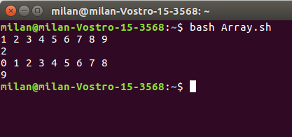

**# Reading values in an array and displaying them**

|  |
| --- |
| **#! bin/bash/**  **echo -n "Enter the size of the array:"**  **read n**  **for((i=0;i<=$(($n-1));i++))**  **do**  **read a[$i]**  **done**  **echo "The array of the given eleements are:"**  **for((i=0;i<=$(($n-1));i++))**  **do**  **echo -n " ${a[i]} "**  **done** |

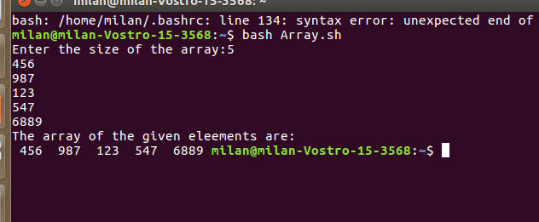

|  |
| --- |
| **a=('dragon ball' 'super')**  **length=${#a[@]}**  **echo "The array is : "**  **for((i=0;i<=$length;i++))**  **do**  **echo -n "${a[i]} "**  **done** |

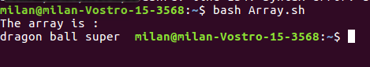

**#SEarching the element**

|  |
| --- |
| **#WAP to search a element from the given array**  **a=(47 0 24 354 42 43 80 87 30 20 10)**  **length=${#a[@]}**  **echo "The given array i : "**  **for((i=0;i<=$length;i++))**  **do**  **echo -n "${a[i]} "**  **done**  **echo " "**  **echo -n "Enter the element you want to searched: "**  **read input**  **j=0**  **flag=0**  **while [ $j -lt $length ]**  **do**  **if [ ${a[j]} -eq $input ]**  **then**  **flag=1**  **echo "Element found at $j"**  **break**  **else**  **j=$((j+1))**  **fi**  **done**  **if [ $flag -eq 0 ]**  **then**  **echo "Element not found"**  **else**  **echo " "**  **fi** |

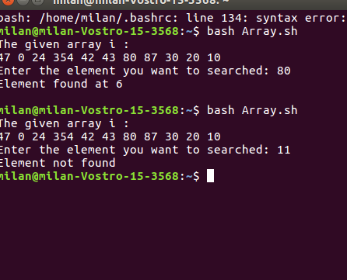

**#Sorting an Array**

|  |
| --- |
| **#WAP to Bubble sort of the following array**  **echo -n "Enter the Size of array"**  **read n**  **#taking input from user**  **echo -n "Enter te numbers in the array : "**  **for ((i=0;i<$n;i++))**  **do**  **read nos[$i]**  **done**  **#printing the elements before sortig**  **echo -n "Numbers in the given array are as follews:"**  **for((i=0;i<$n;i++))**  **do**  **echo -n "${nos[$i]} "**  **done**  **echo " "**  **#Sorting the array:**  **for((i=0;i<$n-1;i++))**  **do**  **for((j=0;j<$n-$i-1;j++))**  **do**  **if [ ${nos[$j]} -gt ${nos[$j+1]} ]**  **then**  **t=${nos[$j]}**  **nos[$j]=${nos[$j+1]}**  **nos[$J+1]=$t**  **fi**  **done**  **done**  **#Printing the sorted array**  **echo -n "Sorted Numbers"**  **for ((i=0;i<$n;i++))**  **do**  **echo -n "${nos[$i]} "**  **done** |

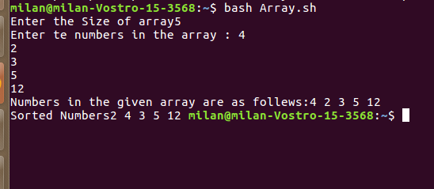

**#SELECTION SORT**

|  |
| --- |
| **echo "enter the number"**  **read n**  **echo "enter number in an array"**  **for((i=0;i<n;i++))**  **do**  **read arr[$i]**  **done**  **#logic for selection sort**  **for((i=0;i<n-1;i++))**  **do**  **small=${arr[$i]}**  **index=$i**  **for((j=i+1;j<n;j++))**  **do**  **if((arr[j]<small))**  **then**  **small=${arr[$j]}**  **index=$j**  **fi**  **done**  **temp=${arr[$i]}**  **arr[$i]=${arr[$index]}**  **arr[$index]=$temp**  **done**  **#printing sorted array**  **echo "printing sorted array"**  **for((i=0;i<n;i++))**  **do**  **echo ${arr[$i]}**  **done** |

